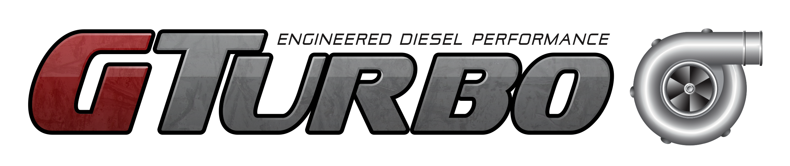
Unit 2/18 Abrams St
Balcatta WA 6021
PH: 0401 524 399

IMORTANT INFORMATION BEFORE INSTALLING TURBOCHARGER

ZD30 TURBOCHARGER INSTRUCTIONS

Please read the following instructions carefully before installing this new turbocharger.

Please understand why you are replacing the turbocharger before installing this new one.

Are you replacing the turbocharger due to failure or engine rebuild?

There are various items that require checking for correct operation and or replacement at this time. Any of these can be attributed to the cause of the original turbocharger failure, and consequently could cause the new turbocharger to fail.

Some common issues that may cause a failure, but are not limited to that which require checking:
- Check for fault codes
- EGR valve/solenoid operation
- Boost control solenoid valve
- Vacuum pump operation
- Air mass sensor
- Air intake pipework and air filter
- In the case of rebuilding the engine, ensure that a new engine oil cooler is fitted at this time

Further research may be necessary to check for other components of faults.

By fitting this new turbocharger you have acknowledged reading and understanding the above.

In the advent of the new turbocharger failing. GTurbo will require it back for the warranty inspection and report. GTurbo’s decision with warranty claims and associated costs will be final.

If you require further assistance or have any questions, please don’t hesitate to contact us.

